A Word from Shaun:
Everyone says they want to be a millionaire, but what they really want is LIFE! The American dream says that more money equates to a better life, however, don’t we all know (or have heard of…) people that have made millions of dollars and are also miserable? I knew one personally… I was one of them!
What I’ve learned through this process is mind-blowing and has radically shifted everything for me for the better. It has literally changed my entire view on finances, and I’ve altered the course of my entire business as a result of what I’m going to share with you. I want to show you how to have all of the money you could ever spend AND have a life in the process!
Because of that, I’m going to strongly encourage you to make it a top priority to show up join us for this. I promise you an eye-opening, paradigm shifting experience in the best possible way.
If you show up with an open mind, you’ll leave awakened to an entirely new perspective on what it means to be successful and prosperous, and you’ll be challenged to a new path – a very specific path you can actually follow, involving four very critical “stages” of personal and business growth.
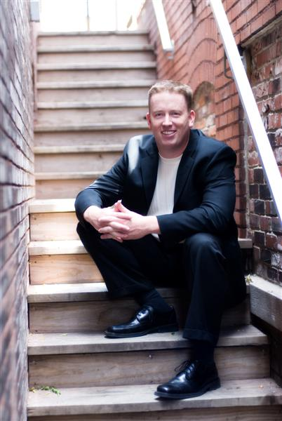
So look, if any of this resonates with you, then for Pete's sake do whatever it takes to join us. I promise it will challenge your current ways of thinking and be a whole lot of fun in the process. :-)
Hope to see you there!

