**Energy Literacy Mission Statement**

To educate the public to be more energy literate. Energy is more than just intermittent electricity from wind and solar. Energy and electricity include thousands of products made from petroleum derivatives that “makes things and moves products,” and the various fuels required by every transportation infrastructure for prosperous societies. Energy literacy will enhance one’s comprehension that the cost of energy affects everything, from the food we eat, the clothes we wear, transportation, communications, housing, healthcare, and the leisurely living made possible by energy.

**Energy Agnostics**

[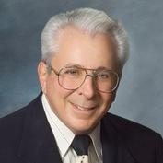](https://www.heartland.org/about-us/who-we-are/ronald-stein-pe)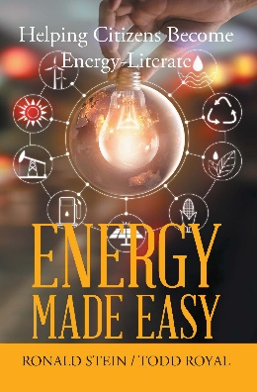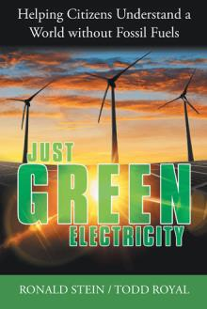

Ronald Stein and Todd Royal are co-authors of the 2019 book [**Energy Made Easy – *Helping Citizens become Energy Literate***](https://www.xlibris.com/en/bookstore/bookdetails/800502-energy-made-easy)– and the new 2020 book [**Just GREEN Electricity – *Helping Citizens Understand a World without Fossil Fuels***](https://www.archwaypublishing.com/Bookstore/BookDetail.aspx?BookId=SKU-001264835)***.***

Ronald Stein, P.E. is an engineer and Founder of PTS Advance, drawing upon decades of project management and business development experiences. He is an internationally published columnist and energy expert who writes frequently about all aspects of energy and economics and is a policy advisor for The Heartland Institute.

Todd Royal is an independent public policy consultant in Los Angeles focusing on the geopolitical implications of energy. His scholarly works are on energy, geopolitics, national security, and foreign policy.

Ron and Todd believe it’s dangerous and delusional to believe anything can be explained in sound bites, much less energy. They will discuss the pros and cons of renewables, coal, natural gas, fuels, and nuclear sources being touted in the press and social media, to meet the needs of societies around the world.

They will make you look at energy and electricity in a new, fresh way, and perspective. They believe this is desperately needed with the upcoming U.S. Presidential election, and global events taking place in China, Russia, Iran, Africa, India, and South America.

Ron and Todd are energy agnostics who only want to share the facts for you to be further energy literate, through their books, Op Ed articles, radio and TV interviews, and in-person presentations, to provide in-depth discussions, and explanations on many energy related subjects such as:

1. *Attaining a better understanding about how the world has changed from societies that existed in primeval times, and the Dark Ages without electricity, transportation systems, or the thousands of products made from the petroleum derivatives that come from a barrel of crude oil.*
2. *Be appreciative as to how the inventions of the automobile, airplane, and the use of petroleum in the early 1900’s led us into the Industrial Revolution. Crude oil, natural gas, and coal changed – for the better – the lifestyles of every person living in developed countries such as, the U.S., Europe, Japan, South Korea, and Australia.*
3. *Time to be cognizant about the dark side of electric vehicles, wind turbines, and solar panels that cannot function without exotic minerals being mined by children and slave labor in countries like the Congo in Africa, and China. The mere extraction of those exotic minerals used in the batteries of EVs and in the wind and solar systems presents social challenges, human rights abuses, and environmental degradations.*
4. *Be mindful of how the world changed with the infrastructures of airlines, trains, vehicles, merchant ships, medications, fertilizers, cosmetics, and military equipment like aircraft carriers, battleships, planes, tanks and armor, trucks, troop carriers, and weaponry that did not exist before 1900. Everyone one of the pieces and parts of a thriving society and the world have exploded to meet the growing demands of society and the creative capabilities of today’s minds are demanding more and better products to enhance our lifestyles.*
5. *Take notice as to why China and India, the two most populous countries in the world with billions of people, are rejecting renewables for coal fired power plants. How China and India use energy is obviously of great importance to world emissions levels, since coal is the dirtiest form of scalable, reliable, affordable, and abundant energy currently available to billions of people hungry for reliable electricity in the developing world.*
6. *Awareness as to why Germany, Australia, and the United States are attempting to take on the leadership to convert the world from fossil fuels and all the derivatives that emanate from petroleum to makes things and move products around the world. Closer to home, why does the state of California import electricity, and why is California the ONLY state in the continental USA that imports most of its crude oil needs from foreign countries?*
7. *Learn about the climate alarmists who benefit from the all-electric narrative, since wind and solar electricity never accounts for the thousands of products that come from petroleum derivatives to “make things and move products”.*
8. *Understand how every part in wind turbines and solar panels comes from the derivatives from petroleum, and if the world’s largest economy – the United States – shut down everything that caused emissions, including human life, emissions will still grow, because of China, India, and Africa. Literally, the U.S. could have 100% reductions in CO2 emissions, and global emissions will rise, because of China, India, and Africa, and their prolific usage of coal.*

By effectively communicating their in-depth research within their books and Op Ed articles via in-person presentations an discussions, they desire to help students, organizations, government leaders, and all residents to be better informed about all thing’s energy related and to be energy literate about the many facets of renewable energies and fossil fuels that support lifestyles and economies around the world.

**Ronald Stein Todd Royal**

Ambassador for Energy & Infrastructure Independent Public Policy Consultant

[Ronald.Stein@PTSadvance.com](mailto:Ronald.Stein@PTSadvance.com) [ToddRoyal@yahoo.com](mailto:ToddRoyal@yahoo.com)

Twitter: @PTSFounder Twitter: @TCR_Consulting

Cell 949-306-6604 Cell: 818-235-2055