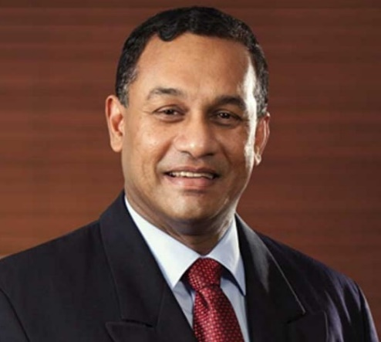
Dr Ravi FERNANDO is an Alumni of the University of Cambridge having completed both a Post Graduate Certificate in Sustainable business in 2008 and a Master of Studies in Sustainability Leadership in 2014. He holds a Doctor of Business Administration Degree from the European Business School in 2016. He completed the Advanced Management Program at the INSEAD Business School (France) and is an Executive in Residence since 2010. He has an MBA from the University of Colombo. In April 2020, he created the ‘21st Century Board Leadership Model-MasterClass’© for the Institute of Directors of Luxembourg which is currently run in Luxembourg and Sri Lanka.
He is the Chairman/CEO of Global Strategic Corporate Sustainability Pvt.Ltd, which operates in Luxembourg, Ireland, United Kingdom, Vietnam, and Sri Lanka. His career with Multinationals spanned 1981-2007 with Unilever, Reckitt Benckiser, Smithkline Beecham International covering Africa, Middle East and Asia. He was the first CEO of the Sri Lanka Institute of Nanotechnology 2008-2011 and Operations Director of the Malaysia Blue Ocean Strategy Institute 2011-2016. He was the first UN Global Compact Focal point 2007 and set up the UNGC Sri Lanka Network. He serves on the Boards of Dilmah Ceylon Tea Company, Aitken Spence Plantations Ltd, UN Global Compact, LOLC Holdings, Ceylon Graphene Technologies Ltd, Ceylon Asset Management and Global Strategic Corporate Sustainability Pvt.Ltd. In 2007 he won “Global Strategy Leadership award”, presented to him by Professor Renee Mauborgne of INSEAD at the World Strategy summit. He published ‘Strategic Corporate Sustainability 7 Imperatives for Sustainable Business’ in 2015 and ‘21st Century Leadership to Fight the Code Red for Business’ in 2023.

