Profile for IFA Expert Centre
January 2021
Dr. John Muscedere

Social

LinkedIn: https://www.linkedin.com/in/john-muscedere-b8849625/
Twitter: @muscedej

Media

It’s time to stop warehousing Canada’s seniors in long-term care – and initiate a bold long-term strategy for healthy aging
Dr. John Muscedere on National Post Radio Mornings with Anthony Furey, Sirius XM.. https://www.cfn-nce.ca/learning-centre/podcasts/

How improving healthcare for the older adults living with frailty can also cut healthcare costs
Dr. John Muscedere Interview by Neeta Das McMurtry for EvidenceNetwork.ca. https://soundcloud.com/evidencenetwork/how-improving-healthcare-for-the-frail-elderly-can-also-cut-costs

AVOID Frailty—February 6, 2020,
Zoomer TV: https://youtu.be/qRL2mtlbNVQ
Combating Frailty—November 16, 2017
Conversations that Matter: https://www.youtube.com/watch?v=mGj9N1cVhrs
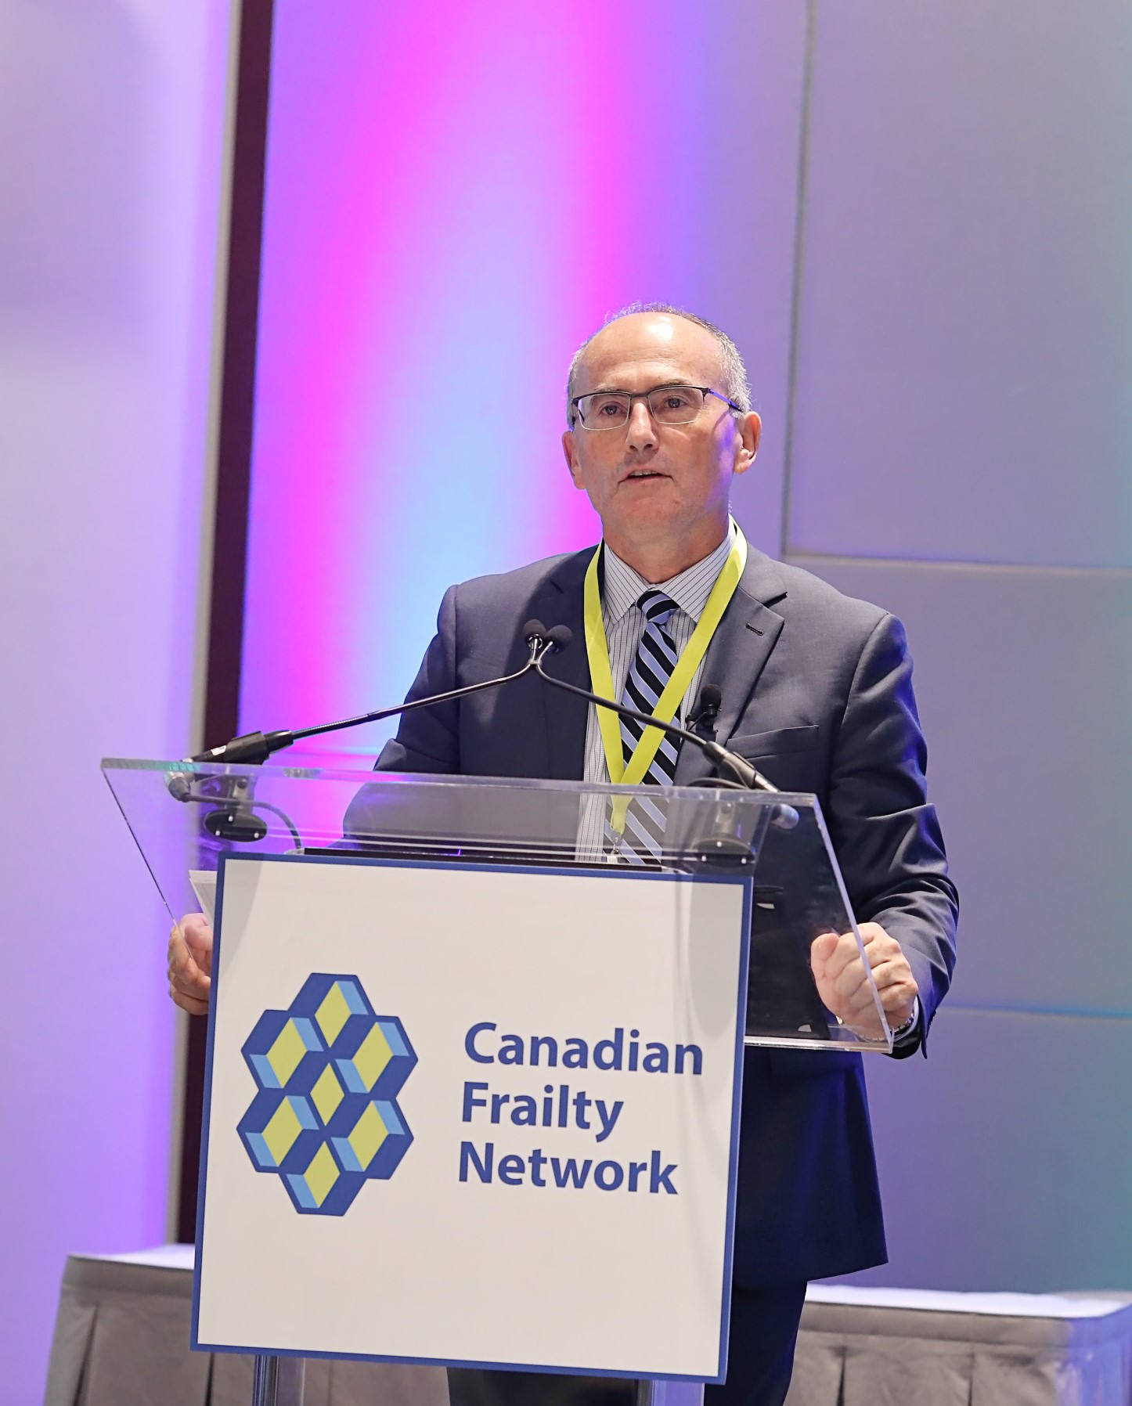


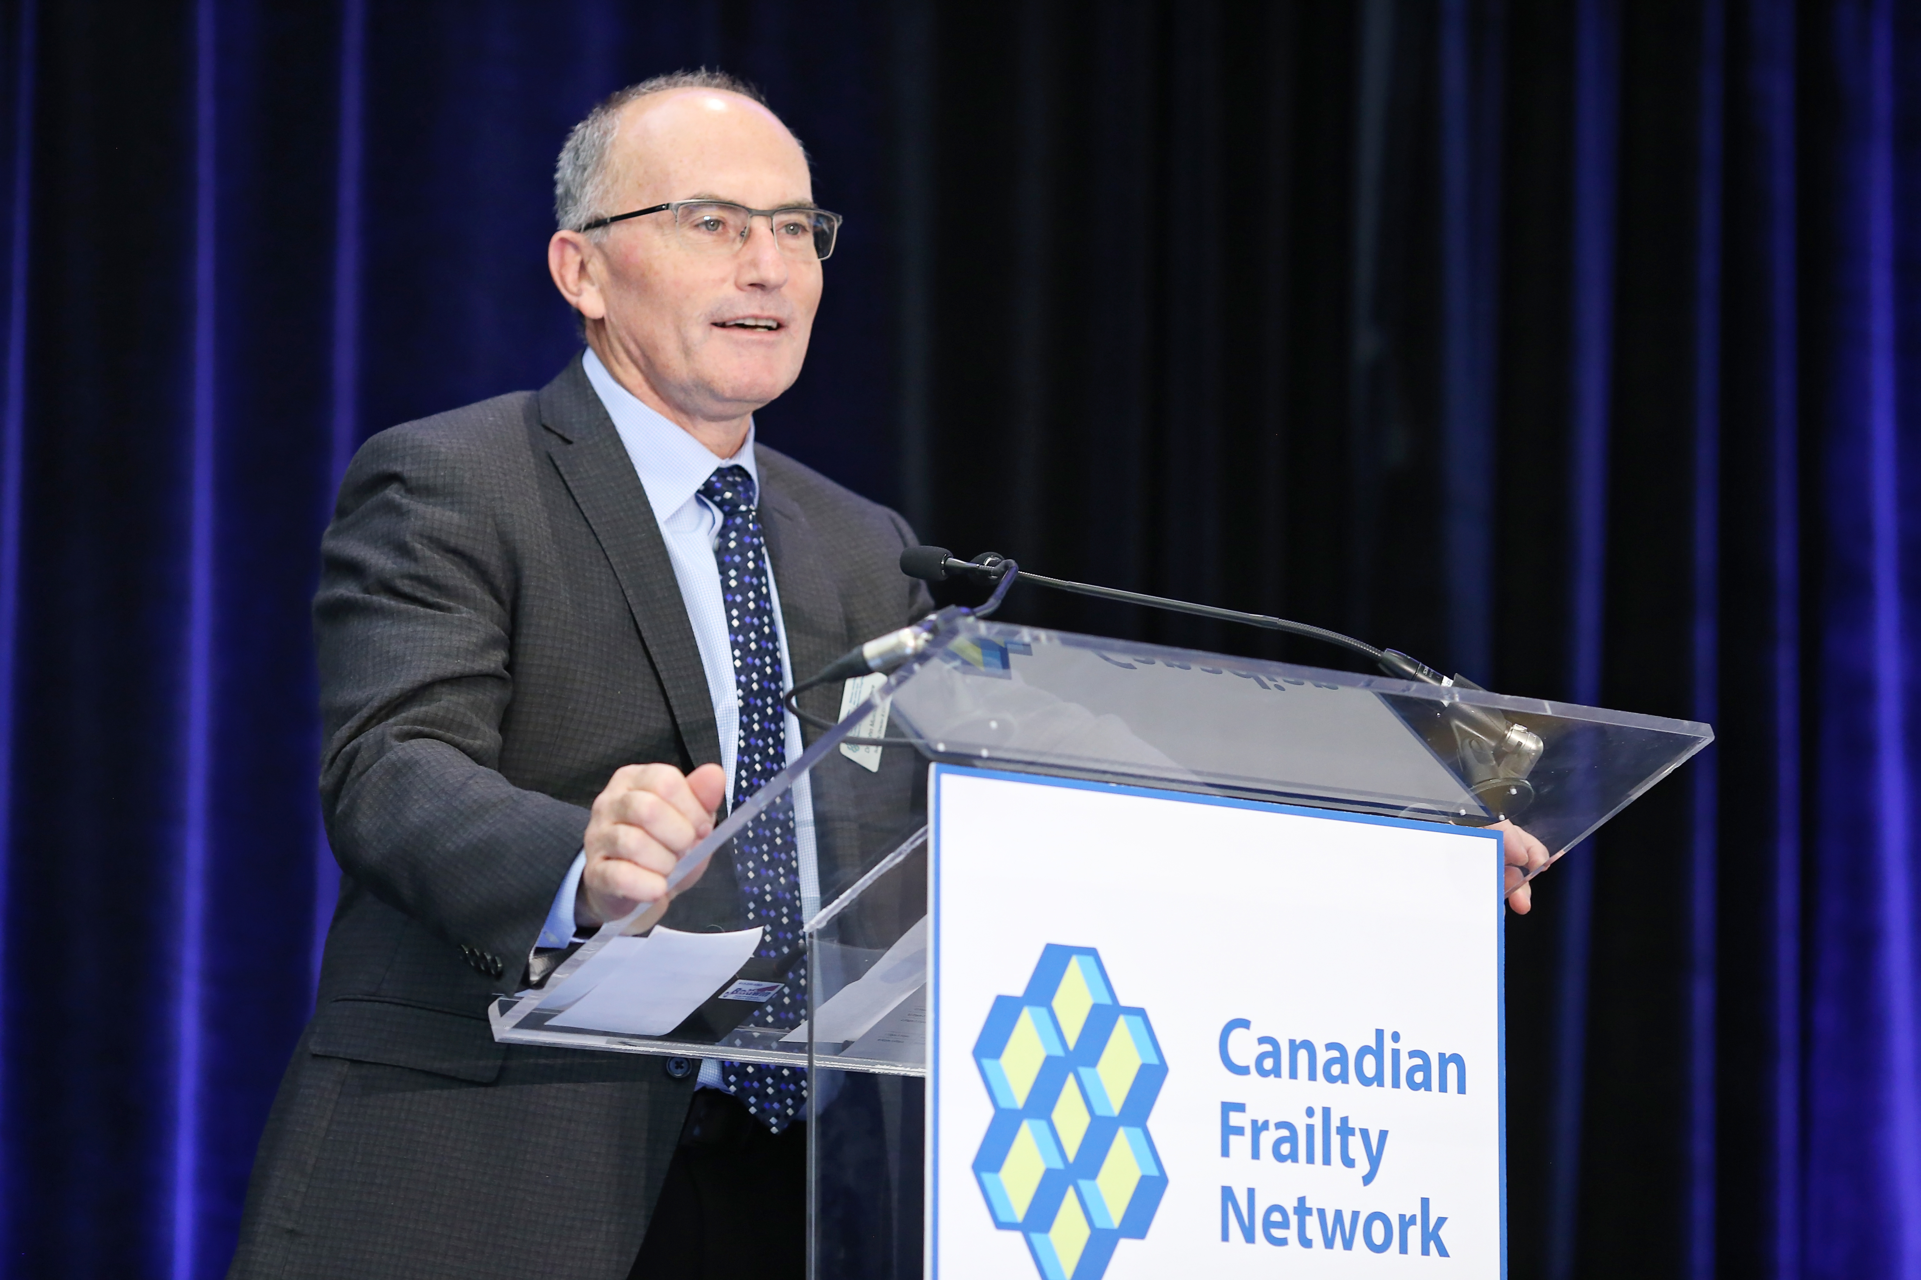

Biography

Dr. John Muscedere MD, FRCPC is a Professor of Medicine at Queen’s University and an Intensivist at Kingston Health Sciences Center in Kingston, Ontario Canada. He is the Research Director for the Department of Critical Care Medicine. Dr. Muscedere has extensive experience in clinical research, both in investigator initiated and industry sponsored research. His research focuses on nosocomial infections, systematic reviews and meta-analyses, clinical trials and the impact of frailty on critical care outcomes.

He is the Scientific Director for the Networks of Centers of Excellence (NCE) funded Canadian Frailty Network (CFN). CFN is dedicated to improving care for older Canadians living with frailly through the generation of new knowledge, knowledge mobilization, development of partnerships and training the next generation of highly qualified personnel.

Areas of Expertise
Critical care, frailty, healthy aging, aging, intensive care

Service Activity
- 2008 to 2015: Member of the Executive, Canadian Critical Care Trials Group
- 2011 to 2016: Deputy Editor for Critical Care, Canadian Respiratory Journal
- 2008 to 2016: Co-Chair, Knowledge Translation Committee of the Canadian Critical Care Trials Group and Canadian Critical Care Society
- 2013 to 2014: Member, Health Quality Ontario’s Expert Advisory Panel on Episode of Care for Pneumonias Presenting to Hospitals
- 2012 to 2014: Subject Matter Expert, Critical Care Services Ontario, Ontario Ministry of Health and Long-Term care
- 2008 to 2012: Chair, Committee for Implementation of Best Practices, Critical Care Secretariat, Ontario Ministry of Health and Long-Term Care
- 2008 to 2011: Leader, Ministry of Health and Long-Term Care Coaching Team for Education and Implementation of Best Practice
- 2007 to 2008: Leader, Ministry of Health and Long-Term Care Coaching Team for Intensivist Led Model of Care in the ICU
- 2006 to 2016: Critical Care Leader, South East Local Health Integrated Network
- 2006 to 2011: Member, Provincial task force on developing admission, discharge and triage criteria for the ICU
- 2005 to 2009: Chair, Advisory Committee to the board of Trillium Gift of Life Network
- 1993 to 2004: Head of Critical Care, Hotel-Dieu Grace Hospital, Windsor, Ontario

Education
1992 Subspecialty Certification in Critical Care Medicine
1992 Subspecialty Certification in Respiratory Medicine

1989 Specialist Certification in Internal Medicine
1985 MD, University of Western Ontario

Affiliations
- Queen’s University
- Kingston Health Sciences Centre
- Canadian Critical Care Trials Group

Links
Canadian Frailty Network

Publications
Frailty and Ageing: Canadian challenges and lessons learned in Denmark–Longwoods, October 5, 2018
Time to Address “Frailty Creepage” in the Canadian Healthcare System. Supplement to The Journal of Frailty and Aging, Vol 7, Number 4, 2018.
We Can’t Address What We Don’t Measure Consistently: Building Consensus on Frailty in Canada — National Institute on Aging/Canadian Frailty Network, 2018
Muscedere J, Waters B, Aditya Varambally et al. The Impact of Frailty on Intensive Care Unit Outcomes: A Systematic Review and Meta-Analysis. Intensive Care Medicine, 2017 Aug; 43:1105-1122. doi: 10.1007/s00134-017-4867-0.
Muscedere, John, Maslove, David M, Boyd, J. Gordon, O’Callaghan, Nicole, Sibley, Stephanie, Lamontagne Francois, Reynolds, Steven, Albert, Martin, Hall, Richard, Jiang, Xuran, Day, Andrew, Jones Gwyneth. Prevention of nosocomial infections in critically ill patients with lactoferrin (PREVAIL Study): a randomized, double blind placebo controlled study. Critical Care Medicine, 2018;46:1450-1456. doi: 10.1097/CCM.0000000000003294.
Andre C. Kalil, Mark L. Metersky, Michael Klompas, John Muscedere et al. Management of Adults With Hospital-acquired and Ventilator-associated Pneumonia: 2016 Clinical Practice Guidelines by the Infectious Diseases Society of America and the American Thoracic Society. Clin Infect Dis. 2016: doi: 10.1093/cid/ciw353.
Screening for Frailty in Canada’s Health Care System: A Time for Action. Canadian Journal on Aging. 2016 Sept; 35(3):281-297. doi: 10.1017/S0714980816000301. Epub 2016 May 23.
Op eds. and Articles
https://www.cfn-nce.ca/news-and-impact/opinions/

